DAA ASSIGNMENT-3
NANDANI RAUNIYAR
CH.SC.U4CSE24261
GRAPH TRAVERSAL

- BFS GRAPH TRAVERSAL:

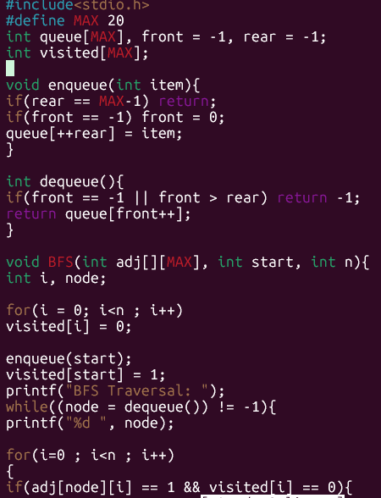
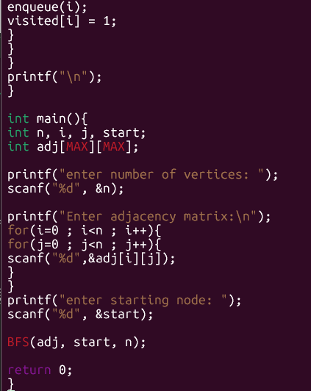

Output:
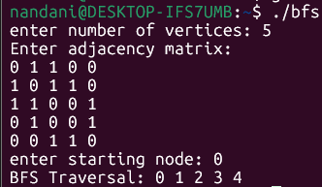

- DFS GRAPH TRAVERSAL:

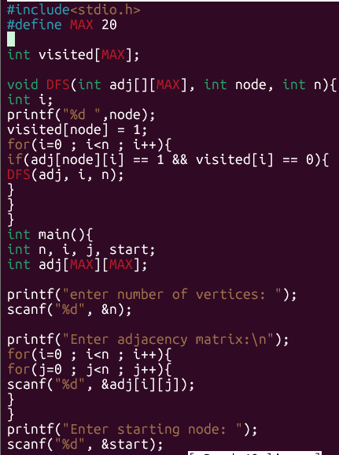
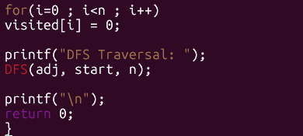

Output:
